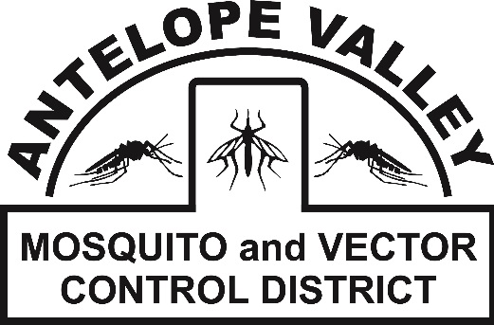 **Antelope Valley Mosquito**

**& Vector Control District**

42624 6th St. East

Lancaster, CA 93535

(661) 942-2917

**www.avmosquito.org**

**NEWS RELEASE**

For Immediate Release

**April 15th, 2025**  **Contact:**

Brenna Bates-Grubb - Community Outreach Specialist

Leann Verdick – District Manager

**As Temperatures Warm, the Antelope Valley Mosquito and Vector Control District Urges Residents to Prepare for Mosquito Season**

**Lancaster, CA**–After a few cold and rainy months, the recent warm weather in the Antelope Valley can mean residents will soon see an increase in mosquito activity. The Antelope Valley Mosquito and Vector Control District (AVMVCD) has joined public health officials, vector control agencies, and cities statewide to promote[California Mosquito Awareness Week](https://urldefense.proofpoint.com/v2/url?u=https-3A__glacvcd.us3.list-2Dmanage.com_track_click-3Fu-3Dae502e59c65793ec56fa87454-26id-3Db9281a8028-26e-3D00019b1202&d=DwMFaQ&c=euGZstcaTDllvimEN8b7jXrwqOf-v5A_CdpgnVfiiMM&r=KdC4BDxpDuP_7rLxeiOTUPowi9ctNMgA1wr_YKs9jmE&m=gtpAfIDKyGJ1CJrdemASSRQ572YRYrpQ6kf3y1P8zMU&s=1aD4GoTmSJX5BD4ANn__JVTNPxIRlWsM0YXzfMJ-eFk&e=) from April 13th through the 19th. This statewide campaign raises awareness about the public health threat mosquitoes pose to our communities and encourages residents to prevent mosquito breeding year-round.  
  
“Residents should inspect their property and eliminate any stagnant water they can find. Rain events and yard irrigation leave standing water in backyards, creating perfect conditions for mosquitoes to develop” said Brenna Bates Grubb, Community Outreach Specialist at the AVMVCD.

While the District monitors and controls mosquito populations in public spaces year-round, other common sources of mosquitoes include residential yards, patios and neglected swimming pools. “Mosquito Awareness Week is a reminder that mosquitoes are very much an issue in the Antelope Valley, and we all need to work together to remove standing water to protect our communities from disease-spreading mosquitoes,” said Bates-Grubb “No water equals no mosquitoes."  
  
West Nile virus has been detected in the Antelope Valley every season for over 20 years. Mosquito control is a shared responsibility between the District and the residents. In order to reduce the local mosquito population, residents must take an active role in reducing the threat of mosquitoes and mosquito-transmitted diseases in their neighborhoods by taking the following steps:

* Report neglected (green) swimming pools in your neighborhood to the Antelope Valley Mosquito and Vector Control District. We will treat it to prevent mosquitoes until the pool can be maintained or drained.
* Wear EPA-recommended insect repellent when outdoors where mosquitoes may be present. Be sure it contains ONE of these main ingredients: DEET, Picaridin, Oil of Lemon Eucalyptus or IR3535. Always follow label instructions
* Eliminate standing water in clogged rain gutters, rain barrels, discarded tires, buckets, watering troughs or anything that holds water for over a week.
* Ensure that swimming pools, spas, and ponds are properly maintained OR drained COMPLETELY dry.
* Change the water in pet dishes, birdbaths, and other small containers weekly.
* Request mosquitofish from your local vector control district for placement in ornamental ponds.

To stay up-to-date on any mosquito related information, check out our website at [www.avmosquito.org](http://www.avmosquito.org)

To report an unmaintained pool, standing water or a mosquito nuisance, use our Submit-a-Tip form at [www.avmosquito.org/submit-a-tip](http://www.avmosquito.org/submit-a-tip)

For any further questions or services please feel free to contact the Antelope Valley Mosquito & Vector Control District by phone **(661-942-2917).**

**For updates and mosquito control tips, follow us on social media:**

 Facebook Instagram: Twitter:

