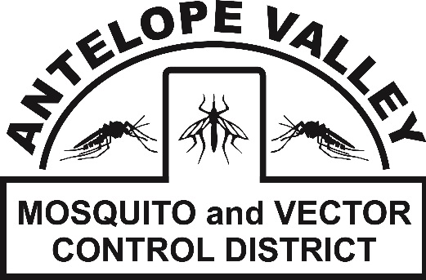
Antelope Valley Mosquito
& Vector Control District
42624 6th St. East
Lancaster, CA 93535
(661) 942-2917
www.avmosquito.org

NEWS RELEASE

For Immediate Release

March 13th, 2026 Contact:
Brenna Bates-Grubb - Community Outreach Specialist
Leann Verdick – District Manager

Antelope Valley Mosquito District Reminds Residents to Take Proper Mosquito Control Measures

Lancaster, CA –There is an unprecedented heatwave hitting the Antelope Valley over the next few weeks. With the heatwave occurring after some major rains, there are a lot of opportunities for mosquitoes to breed in stagnant water. While mosquito season hasn’t kicked back into full gear yet, we are well on our way to an active mosquito season. The early mosquito detections and resident alerts to the District about mosquito activity have prompted us to remind the community about the importance of taking proper personal mosquito control measures.

Mosquitoes are much more than a nuisance, they are a real public health threat. West Nile virus is endemic to the Antelope Valley and is currently established in the local Culex mosquito population. West Nile virus is the most prevalent and serious mosquito-borne disease in California. Every warm season since 2004, the District has detected the presence of West Nile virus circulating in the environment throughout the Antelope Valley. There is no human vaccine for West Nile virus, a disease which can cause debilitating cases of meningitis, encephalitis, and even death. The District urges the community to report any mosquito activity, standing water or unmaintained swimming pools to us at 661.942.2917 or www.avmosquito.org/submit-a-tip . Keeping mosquito populations low remains of utmost importance due to the potential of mosquito-borne illness. The lower the mosquito population, the lower the likelihood for disease transmission.

AVMVCD personnel are continuing mosquito surveillance and control efforts and will proceed to keep residents informed regarding important mosquito control updates. The public plays a critical role in helping to control the spread of mosquitoes and all residents are advised to do their part around their homes and properties to eliminate them.

Also, an important note is that there are many mosquito look-alikes in the Antelope Valley. The District has been receiving a lot of calls and worry about crane flies. Crane flies are a major mosquito look-alike but they are harmless, don’t bite and don’t spread disease. If you are noticing ‘giant’ mosquitoes, they are more than likely crane flies. Mosquitoes in the Antelope Valley aren’t much larger than the eraser head of a pencil.
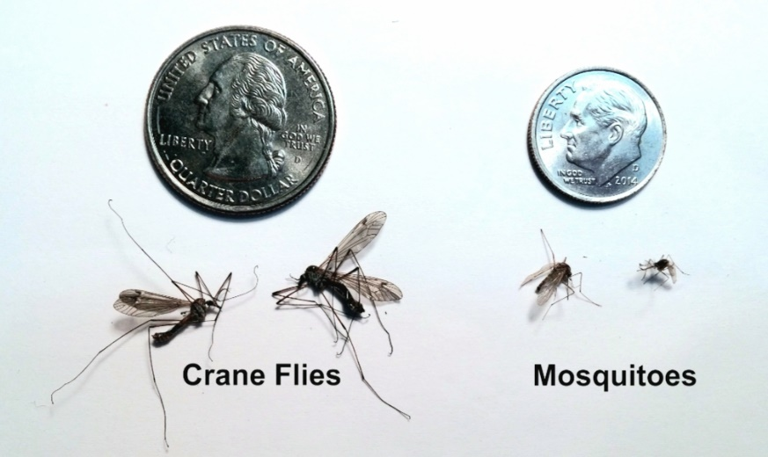

All possible sources of standing water where mosquitoes lay eggs such as buckets, tires, toys, plant saucers and so on, should be emptied of standing water. Scrubbing the insides of the containers is also recommended, as this will dislodge eggs that are stuck to the container. The District also urges residents to do their part to protect themselves from mosquito bites by following these recommendations:
- Wear insect repellent that contains one of these main ingredients: DEET, picaridin, oil of lemon eucalyptus, or IR3535 to exposed skin (as directed on the product label).
- Wear long sleeve shirts, long pants, socks and shoes when mosquitoes are active, weather permitting.
- Be sure window and door screens are in good repair to prevent mosquitoes from entering your home.
- Inspect yards for standing water sources and drain water that may have collected under potted plants, in bird baths, discarded tires, and any other items that could collect water.
- Check your rain gutters and lawn drains to make sure they aren’t holding water and debris.
- Clean and scrub bird baths and pet watering dishes weekly.
- Change indoor plant water (i.e. Bamboo and Philodendron) as necessary to avoid mosquito breeding.

If you notice and abundance of day biting mosquitoes, report them to the District by calling (661) 942-2917 or scanning here to report online:


To stay up-to-date on any mosquito related information, check out our website at www.avmosquito.org.

For any further questions or services please feel free to contact the Antelope Valley Mosquito & Vector Control District by phone (661-942-2917). Follow us on social media:


Facebook Instagram: X:





