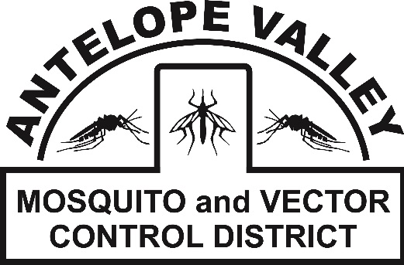 **Antelope Valley Mosquito**

**& Vector Control District**

42624 6th St. East

Lancaster, CA 93535

(661) 942-2917

**www.avmosquito.org**

**NEWS RELEASE**

For Immediate Release

**July 30, 2025**  **Contact:**

Brenna Bates-Grubb - Community Outreach Specialist

Zachary Russell – Mosquito Surveillance Technician

**Mid-Mosquito Season Reminder: Stay Vigilant as West Nile Virus Remains a Threat in Southern California**

**Lancaster, California** – As summer reaches its peak, the Antelope Valley Mosquito and Vector Control District (AVMVCD) would like remind residents that mosquito season is in full swing—and so is the risk of mosquito-borne illness like West Nile virus (WNV), which remains endemic in the Antelope Valley.

The District is urging individuals to take proactive steps to reduce their exposure to mosquitoes and the potentially serious diseases they carry. West Nile virus, which is spread to humans through the bite of an infected mosquito, is the most common mosquito-borne disease in the United States and has been detected in the Antelope Valley region every year since 2004.

So far, our surveillance efforts have not detected WNV locally during the 2025 mosquito season. While we have not identified any West Nile virus-positive mosquito samples in our area in 2025 to date, this does not equate to an absence of risk. Surveillance data is only a snapshot, and undetected or emerging transmission is always a possibility. Residents are urged to remain vigilant with prevention efforts, especially as mosquito activity peaks during the summer months.

"Southern California's warm weather and standing water from irrigation, pools, and ornamental landscaping all come together to make an ideal breeding ground for mosquitoes," said Brenna Bates-Grubb, Community Outreach Specialist at the Antelope Valley Mosquito and Vector Control District "We're entering the time of year when mosquito activity peaks, and it only takes one bite from an infected mosquito to get sick."

**Simple Steps to Stay Mosquito-Free**

The District recommends the following steps to protect yourself and your family from mosquito bites and reduce mosquito breeding around your home:

1. **Dump and Drain Standing Water**  
   Mosquitoes lay their eggs in stagnant water. At least once a week, empty and scrub items that hold water, such as flowerpots, birdbaths, pet bowls, plant saucers, buckets, and toys.
2. **Secure Screens and Doors**  
   Repair or replace torn window and door screens to keep mosquitoes outside.
3. **Use EPA-Registered Repellents**  
   Apply insect repellent containing DEET, picaridin, IR3535, or oil of lemon eucalyptus when spending time outdoors, especially during dawn and dusk when mosquitoes are most active.
4. **Dress to Protect**  
   Wear long sleeves, long pants, and socks when outside, particularly in mosquito-prone areas such as parks, gardens, and trails.
5. **Maintain Pools and Fountains**  
   Keep swimming pools well-maintained and chlorinated, and ensure fountains are functioning properly to prevent standing water.
6. **Report Mosquito Problems**  
   If you notice unusual mosquito activity or neglected swimming pools, report them to the District at 661-942-2917, at [www.avmosquito.org/submit-a-tip](http://www.avmosquito.org/submit-a-tip) or by scanning the QR code below:



"Community involvement is critical," added Leann Verdick, District Manager at the AVMVCD. "Mosquitoes don’t respect property lines. When everyone takes steps to eliminate breeding grounds and protect themselves, we all benefit."

To learn more about mosquito control and West Nile virus prevention, visit <https://westnile.ca.gov/> or <https://www.avmosquito.org/do-it-yourself-solutions>

To stay up-to-date on any mosquito related information, check out our website at [www.avmosquito.org](http://www.avmosquito.org).

For any further questions or services please feel free to contact the Antelope Valley Mosquito & Vector Control District by phone (661-942-2917).

Follow us on social media:

 Facebook Instagram:

###