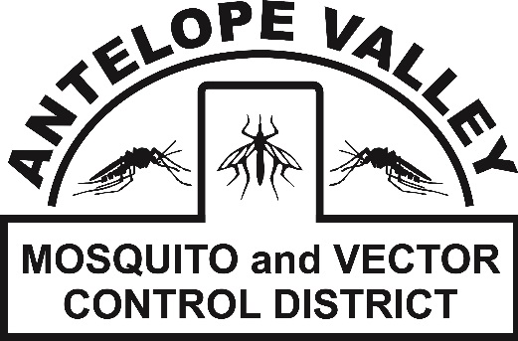
Antelope Valley Mosquito
& Vector Control District
42624 6th St. East
Lancaster, CA 93535
(661) 942-2917
www.avmosquito.org

NEWS RELEASE

For Immediate Release

April 21st, 2026 Contact:
Brenna Bates-Grubb- Community Outreach Specialist
Zachary Russell- Surveillance Technician

First Invasive Aedes Mosquito Detection in Lancaster for the 2026 Mosquito Season

Lancaster, CA – The Antelope Valley Mosquito and Vector Control District has detected a sample of the invasive Aedes mosquito for the first time this 2026 mosquito season. The sample was collected near 25th Street East and Avenue J-10. District Surveillance Technician, Zachary Russell, identified these samples as Aedes aegypti, “This invasive mosquito was first discovered in the Antelope Valley in October of 2018, and has been spreading exponentially throughout the Antelope Valley since then. They are also known as the yellow fever mosquito and commonly referred to as “ankle biters”, Russell states. This re-emergence highlights the importance of the community taking proper mosquito control measures to help keep this mosquito population lowered.

The Aedes aegypti is a small black and white mosquito that is closely associated with human dwellings. Unlike our native Culex mosquitoes that generally bite during dusk and dawn and tend to be less aggressive, Aedes mosquitoes will actively pursue people throughout the entire day and into the evening.

Invasive Aedes mosquitoes feed almost exclusively on humans, biting aggressively all day long. Female mosquitoes will lay eggs just above the water line in small containers such as vases, flower pot saucers, toys, discarded litter and so on. The eggs can dry up and survive for six or more months or even up to several years if conditions are ideal, waiting for the container to re-flood so they can hatch. Be sure to rinse and scrub containers that plants are in at least weekly to dislodge and kill any mosquito eggs and immature mosquitoes, even if the containers are inside the home. Due to the close association with humans, Aedes mosquitoes will not hesitate to take up residence inside your home or office.

Aedes aegypti have the potential to carry very different diseases than our native Culex mosquitoes and are known transmitters of diseases like yellow fever, dengue fever, chikungunya, and Zika virus. “Although these mosquitoes have the potential to carry these diseases, there is currently no indication of local transmission occurring,” said District Manager Leann Verdick. “Keeping mosquito populations low remains of utmost importance due to the potential for these diseases to make their way into the mosquito population,” states Verdick.

AVMVCD personnel have increased mosquito surveillance in these areas and will continue to place traps that are designed to attract egg-laying Aedes mosquitoes. In addition to increased surveillance efforts, residents in the surrounding area are advised to do their part to eliminate this mosquito.

The public plays a critical role in helping to control the spread of this mosquito population. All possible sources of standing water where mosquitoes lay eggs such as buckets, trash, and plant saucers should be emptied of standing water or disposed of properly. Scrubbing the insides of the containers is also recommended, as this can dislodge eggs deposited above the water line. The District also urges residents to do their part to protect themselves from mosquito bites by following these recommendations:
- Wear EPA registered ingredients such as DEET, picaridin, oil of lemon eucalyptus, or IR3535 to exposed skin and/or clothing (as directed on the product label).
- Wear loose-fitting, long sleeve shirts, long pants, socks and shoes when mosquitoes are most active.
- Be sure window and door screens are in good repair to prevent mosquitoes from entering your home.
- Inspect yards for standing water sources and drain water that may have collected under potted plants, in bird baths, discarded cans/bottles, and any other items that could collect water.
- Check your rain gutters and lawn drains to make sure they aren’t holding water and debris.
- Clean and scrub bird baths and pet watering dishes at least weekly.
- Check indoor plants that are kept in standing water for mosquito activity (i.e. Bamboo and Philodendron)

Report any day-time biting mosquitoes to the AVMVCD at 661-942-2917 or at www.avmosquito.org/submit-a-tip

Learn more about Aedes mosquitoes at: https://www.avmosquito.org/invasive-aedes-mosquitoes

To stay up-to-date on any mosquito related information check out our website at www.avmosquito.org, Facebook page (https://www.facebook.com/avmosquito) and Instagram @AVMosquito.

For any further questions or services please feel free to contact the Antelope Valley Mosquito & Vector Control District by phone (661-942-2917).

###

